**tar command:**

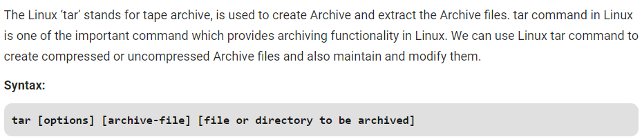

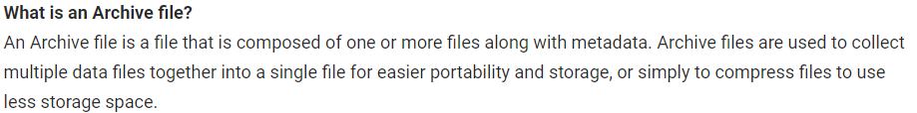

**Options:**

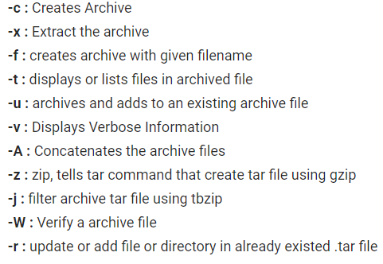

**Creating an uncompressed tar Archive using option -cvf:** This command creates a tar file called file.tar which is the Archive of all .c files in current directory.

* **tar cf file.tar *.c**
* **tar cvf file.tar *.c 🡪 verbosely compresses**

**Extracting files from Archive using option -xvf:** This command extracts files from Archives.

* **tar xf file.tar**
* **tar xvf file.tar 🡪 verbosely extracts**

**gzip compression on the tar Archive, using option -z:** This command creates a tar file called file.tar.gz which is the Archive of .c files.

* **tar cvzf file.tar.gz *.c**

**Extracting a gzip tar Archive *.tar.gz using option -xvzf**: This command extracts files from tar archived file.tar.gz files.

* **tar xvzf file.tar.gz**

**Creating compressed tar archive file in Linux using option -j**: This command compresses and creates archive file less than the size of the gzip. Both compress and decompress takes more time then gzip.

* **tar cvfj file.tar.tbz example.cpp**

**Untar single tar file or specified directory in Linux:** This command will Untar a file in current directory or in a specified directory using -C option.

* **tar xvfj file.tar**

**or**

* **tar xvfj file.tar -C path of file in directoy**

**Untar multiple .tar, .tar.gz, .tar.tbz file in Linux:** This command will extract or untar multiple files from the tar, tar.gz and tar.bz2 archive file. For example, the above command will extract “fileA” “fileB” from the archive files.

* **tar xvf file.tar "fileA" "fileB"**

**or**

* **tar zxvf file1.tar.gz "fileA" "fileB"**

**or**

* **tar jxvf file2.tar.tbz "fileA" "fileB"**

**Check size of existing tar, tar.gz, tar.tbz file in Linux:** The above command will display the size of archive file in Kilobytes(KB).

* **tar czf file.tar | wc -c**

**or**

* **tar czf file1.tar.gz | wc -c**

**or**

* **tar czf file2.tar.tbz | wc -c**

**Update existing tar file in Linux**

* **tar rvf file.tar *.c**

**Applying pipe to through ‘grep command’ to find what we are looking for:** This command will list only for the mentioned text or image in grep from archived file.

* **tar tvf file.tar | grep "text to find"**

**or**

* **tar tvf file.tar | grep "filename.file extension"**

**We can pass a file name as an argument to search a tarfile:** This command views the archived files along with their details.

* **tar tvf file.tar filename**

**Viewing the Archive using option -tvf**

* **tar tvf file.tar**

**create tar with bzip2 compression**

* **tar cjf file.tar.bz2**

**extract tar with bzip2**

* **tar xjf file.tar.bz2**